Selfmodelling 自我重建模朱望舒，Prof. Andre Rosendo

Summer 2018

在现代工业体系中，机器人是极其重要的一环。近年来，为提高产品质量、降低成本、缩短研制周期，制订多项先进制造发展战略与规划，调整产业架构, 促进产业转型，自动化机器人体系有了爆发式的发展与应用。特别是大规模下的工厂中，比如汽车船舶等行业中，自动化机器人体系有着无可替代的作用。而其中最为广泛应用的就是工业机械臂，它在流水线上可以更强、更精、更快地完成任务。但是也是因为其高强度的工作，难免会有关节出现故障，或者工厂需要定期进行保养来减少故障的几率。我们提出了一种新的自我重建模方法，使机械臂在某些关节被固定的情况下，依旧能够完成原先任务、到达指定点位。

一、研究背景

工业机器人是面向工业领域的多关节机械手或多自由度的机器装置，它能自动执行工作，是靠自身动力和控制能力来实现各种功能的一种机器。它可以接受人类指挥，也可以按照预先编排的程序运行，现代的工业机器人还可以根据人工智能技术制定的原则纲领行动。在现在工业体系中，它占据了很大的市场。

在全球范围内，2015 年全球工业机器人销量为 24.8 万台，同比增长 12%， 随着人力成本的逐渐上升以及品质要求的提升，工业机器人正逐步取代人力，成为生产中的重要自动化装备。自 2013 年以来，中国已成为全球工业机器人最大的消费国。据中商产业研究院《2016-2021 年中国工业机器人市场调研及前景预测报告》显示，2014 年中国工业机器人销量约为 5.7 万台，同比增长 56.2%，占全球总销量的 1/4。

在工业机器人中，工业机械臂更为广泛地应用于流水线上。但是由于其高强度的工作，有些关节难免会出现故障。但是一旦在一条流水线上有一台机械臂出现故障，没有办法完成任务，那么一般来说工厂会停下整条流水线进行维修。但是这么做的话，每分钟大约会损失 200000RMB，这是极大的损失。

所以我们提出了一种新的自我重建模方法，使机械臂在某些关节被固定的情况下，依旧能够完成原先任务、到达指定点位。这样就可以在一定程度上继续工作，大幅减小损失。

二、方案设计

* 1. 引言

机械臂正运动学( Kinematic )和逆运动学( Inverse Kinematic )的求解是机械臂实际控制中需要解决的基本问题。其中逆运动学的求解比正运动学求解更加复杂，对于不同的机械臂构型没有标准的求解方法和步骤。一般机械臂逆运动学的求解方法主要有解析法、数值迭代法、几何法等。

解析法的优势在于使用该方法可以求解出所有的根，还可以证明根不存在的情况；缺点在于这种方法一般都非常的繁琐，需要大量的计算。数值迭代法的优

势在于使用这种方法计算相对简单，可以求解出大部分机械臂的逆解，但每次迭代在给定预期初值的情况下，最终只能获得一组解，如果解不存在，数值迭代将无法收敛。几何法可以对某些特殊的模型进行简化，并利用几何关系求解，但是它一般需要和解析法配合使用。

报告主要针对 Kinova Jaco2 6DOF 手臂进行研究，研究其正逆运动学特性，并实现了在固定一个关节的情况下，继续完成抓取移动任务。

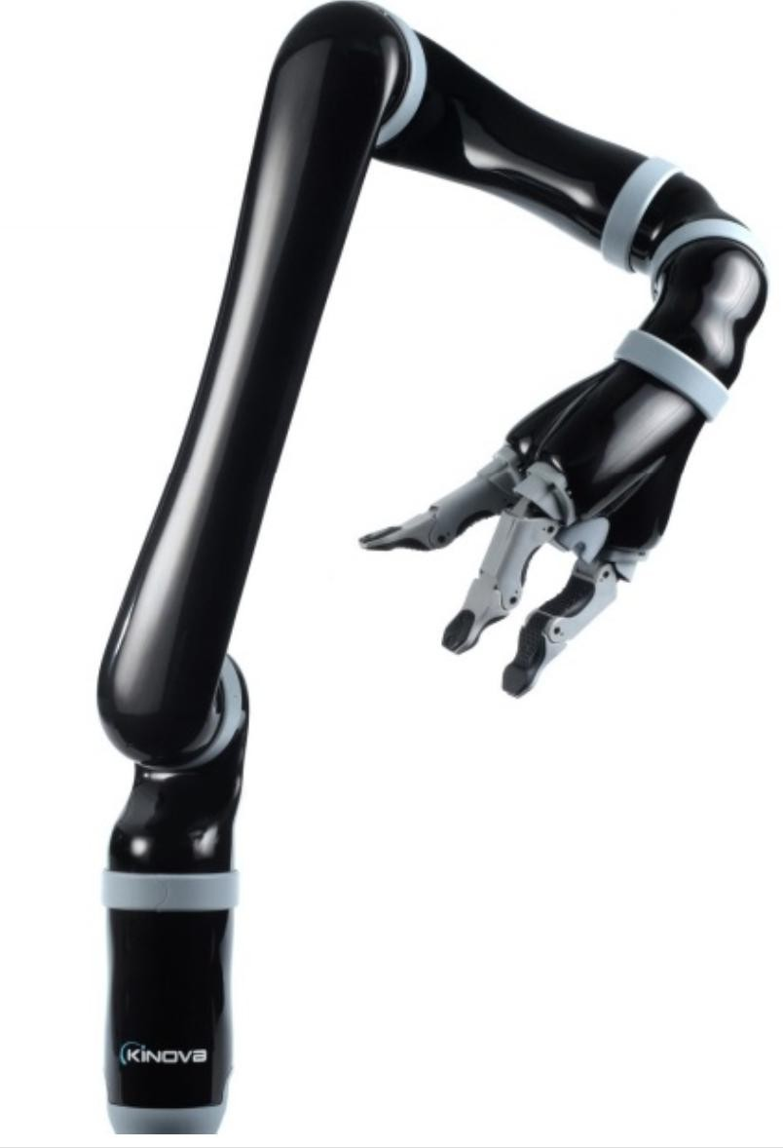

* 1. 正运动学模型求解

要研究机械臂的运动，就必须建立他的运动学模型，在通过运动学模型求解正、逆运动学。一般通过建立关节坐标系，用数学方法抽象机械臂实体，描述机械臂相对基坐标系的位置和姿态。本文使用通用的DH 参数运动学建模法建模。空间六自由度机械臂构型如图 2a，连杆坐标系的建立如图 2b。

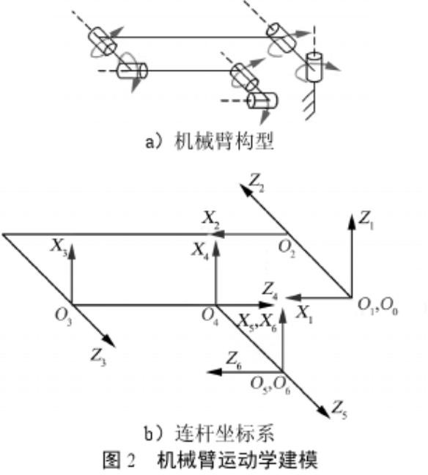

Kinova Jaco2 6DOF 的 DH 模型如下表 Table 1：

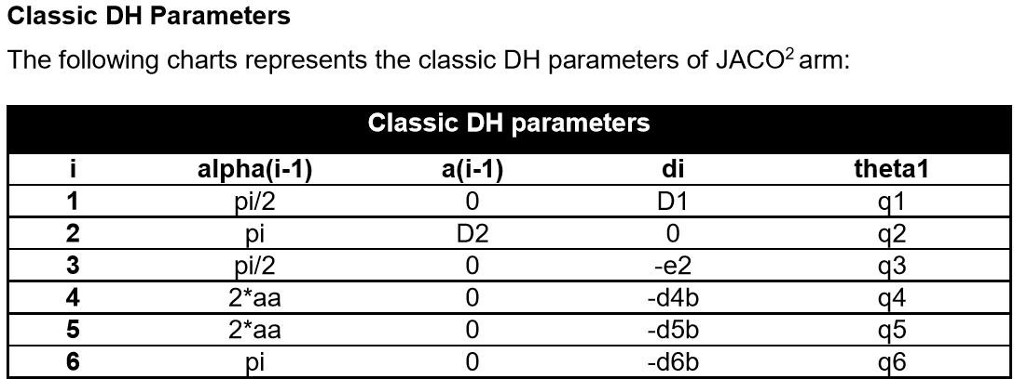

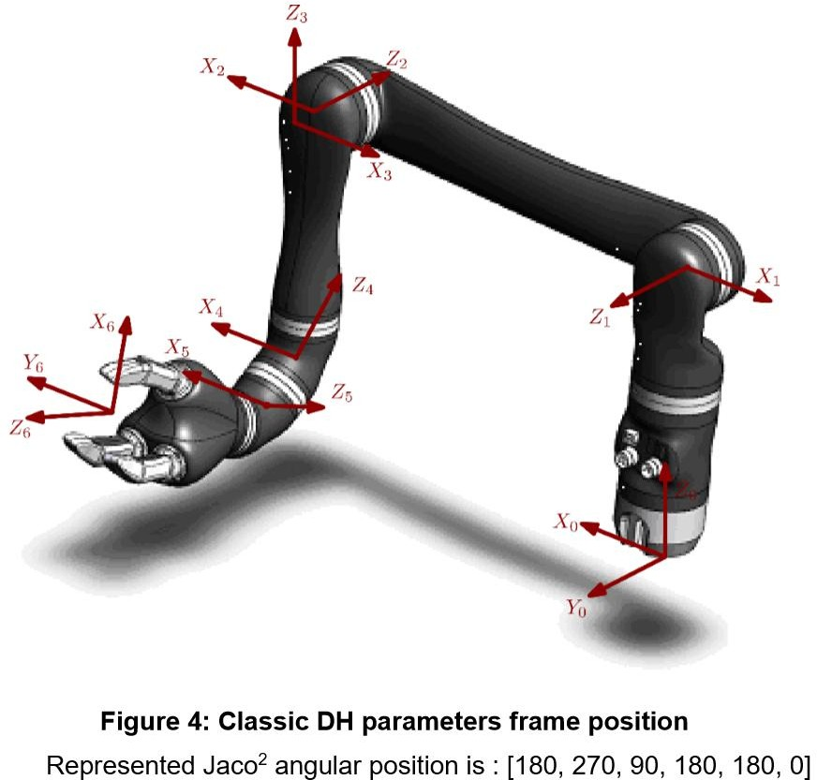

空间六自由度机械臂正运动学的求解问题就是已知机械臂各关节角度值

{θ1，θ2，θ3，θ4，θ5，θ6}，求解机械臂各关节点相对于基坐标系的位姿。

这里我们将引入转换矩阵（transform matrix），其中的四个参数α、a、θ、d 正是上面 DH 模型中的四个参数。每个关节都有一个转换矩阵，我们一共有 6 个关节，就可以得到 6 个转换矩阵 T1、T2、T3、T4、T5、T6。

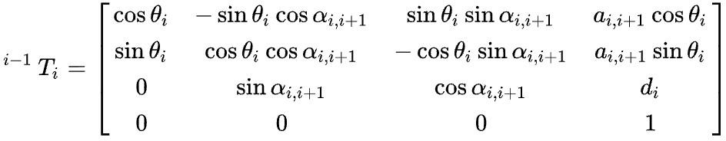

我们把 6 个转换矩阵依次乘以基坐标齐次形式Xbase=[0,0,0,1]T 就可以得到最后机械手的位置。

Xaim=T6*T5*T4*T3*T2*T1*Xbase

* 1. 逆向动力学求解

接着我们介绍逆向动力学，空间六自由度机械臂正运动学的求解问题就是已知机械臂最终的空间位置（以及姿态），求解机械臂各关节的角度。这在实际应用中更具有价值，因为如果掌握了这个技术，就可以控制机械手到我们想要的位置进行工作。

一般机械臂逆运动学的求解法主要有解析法、牛顿迭代法、几何法等。本文使用了牛顿迭代法进行求解，相比解析法等算法，计算相对简单。

使用牛顿迭代法求解逆向动力学的解。首先需要构建非线性方程组：**F**（**θ**）

=0，**F**（**θ**）=（f1,f2,...,f12）T,**θ**=(θ1，θ2，θ3，θ4，θ5，θ6).已知手部坐标系对于基坐标系的齐次变换矩阵Taim，对于每次迭代也可以得到一个齐次变换矩阵 T**θ**（θ1，θ2，θ3，θ4，θ5，θ6），将两者中元素共 12 个一一相减得方程组。

**F**（**θ**）=（T**θ-**Taim）=0

再将上式对 (θ1，θ2，θ3，θ4，θ5，θ6)分别求偏导得到雅可比矩阵 **J**

求解方程组的牛顿迭代公式为

**θ**i+1**=θ**i**-J**-1**F**（**θ**i）

* 1. 关于锁定某关节的研究

本文试在讨论一种在工业流水线上机械臂某关节出现问题，无法到达指定角度的情况。针对我们的六自由度机器人如果一个关节出问题了，那么我们还能到达最后的位置吗？我们认为答案是肯定的。比如第五个关节被锁定了，我们依靠其他关节的调整最后还是能到达指定位置。

我们做了两组各三次对照试验。第一次机械臂正常工作从 A 点运动到指定的B 点。第二次我们在最后输出角度至马达时故意将第五个角度设置为初始角度， 以此模拟关节损坏的情况。第三次依靠牛顿迭代法的自适应特点，将固定的角度输入迭代进行计算，利用其它角度的“配合”，我们依旧可以到达指定位置。最终第五个关节是初始角度，而其他五个关节为相应的不同于第一次试验的角度。

第二组是模拟用机械臂抓取网球再放到指定位置的试验。效果与第一组相似，第一次试验机械臂可以正常地拿放到相应位置。第二次出现了错误。第三次依旧可以完成指定任务。

接下来我们讨论这个方法的一些限制性。首先是机械臂的自由度必须较高， 比如和我们的试验一样原先有 6 个自由度，后来固定 1 个自由度，这样还剩下 5

个自由度理论上还是能到达原先能到的所有位置。如果再锁定 1 或 2 个自由度， 有些位置还是能到达，但是也会出现很多到达不了的位置，这个因机械臂特性而异。

另外在本实验中第五个关节的角度是我们事先设置好的，但在现实工作中， 关节可能会损坏在其他的角度，所以我们需要用一些方法来获取角度。这里我们想到了两种情况第一是关节虽然损坏但传感器还是能工作，这样我们利用传感器读取的角度就可以进行迭代计算。第二如果传感器也损坏了，我们想到用计算机视觉的技术，利用图像判断并计算相应的固定角度。这一部分需要后续继续的研究。

三、实验和结果

这里是第一组实验的路径记录。第一次试验机械臂可以正常地到达指定位置。第二次在锁定第五个关节后出现了错误，未到达指定位置。第三次通过改变迭代角度依旧可以完成指定任务，我们称它为自适应的结果。

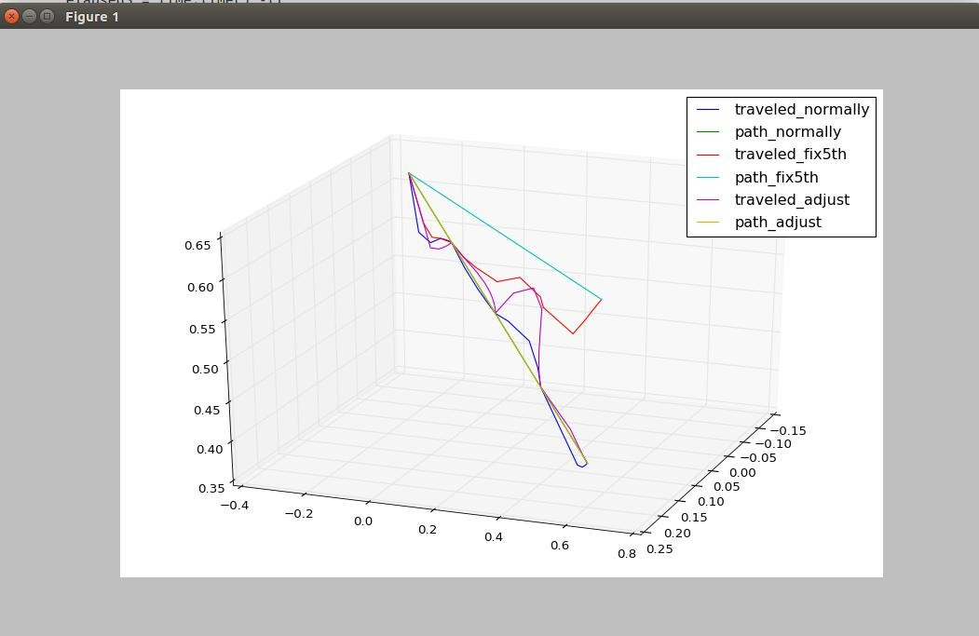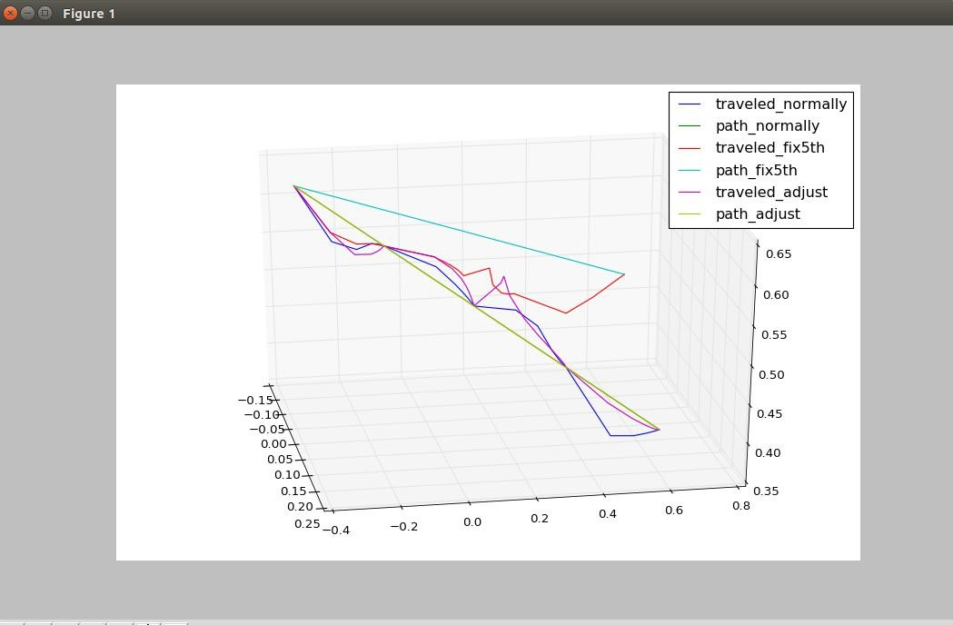

四、总结

本文针对较高自由度工业机械臂，在流水线上难免会有关节出现故障，最后停止整条流水线这个问题。我们提出了一种新的自我重建模方法，使机械臂在某些关节被固定的情况下，依旧能够完成原先任务、到达指定点位。我们称之为自

适应办法。这种方法建立在牛顿迭代法上，因此我们讨论了基本的正逆动力学， DH 模型等方面。我们通过真实的试验证明了这个方法的可行性，而且我们的方法对于不同的多自由度机械臂均适用，可以进行广泛地移植。同时我们也对未来通过计算机视觉技术加入，进行了展望。

参考文献：

1. 基于空间六自由度机械臂的逆运动学数值解法_张栩曼
2. Mobile Robotics Mathematics, Models, and Methods-Alonzo Kelly
3. Introduction to Autonomous Mobile Robots-Roland Siegwart,Illah R. Nourbakhsh, Davide Scaramuzza

Selfmodelling

Zhu Wangshu，Prof. Andre Rosendo Summer 2018

In the modern industrial system, the robot is an extremely important part. In recent years, in order to improve products’ quality, reduce cost and shorten development cycle, the development strategies and plans of several advanced manufacturing developments have been formulated. Industrial structure has been adjusted. Industrial transformation has been promoted. And automatic robot system has achieved explosive development and application. Especially in large-scale factories, such as automobile and ship industries, automatic robot system plays an irreplaceable role. The manipulator is one of the most widely used robots, which can be stronger, more refined and faster to complete tasks on the assembly line. However, due to its high intensity of work, it is inevitable that there will be failures, or the factory needs regular maintenance to reduce the probability of failure. We propose a new method of self-remodelling to enable the robot arm to complete the original task and reach the specified point when some joints are fixed.

* 1. Research background

Industrial robot can be a multi-joint manipulator or multi-dof machine device oriented to the industrial field. It can perform work automatically. It is a kind of machine that realizes various functions by its own power and control ability. It can be directed by humans or run according to pre-programmed programs, and modern industrial robots can even act according to principles developed by AI technologies. In today's industrial system, it's a big market. Worldwide, the global sales volume of industrial robots in 2015 was 248,000, an increase of 12% year on year. With the gradual increase of human cost and the improvement of quality requirements, industrial robots are gradually replacing human labor and becoming an important automation equipment in production. Since 2013, China has become the world's largest consumer of industrial robots. About 57,000 industrial robots were sold in China in 2014, up 56.2 percent year-on-year, accounting for a quarter of the total global sales, according to the 2016 -- 2021 China industrial robot market research and prospect forecast report by the China business industry research institute. In industrial robot, industrial robot arm is more widely used on assembly line. However, due to its high intensity of work, some joints will inevitably fail. But if one of the mechanical arms fails on an assembly line and there is no way to complete the task, the factory will normally stop the entire assembly line for maintenance. But if you do that, you will lose about 200,000rmb per minute, which is a huge loss. Therefore, we propose a new method of self-remodelling, which enables the mechanical arm to complete the original task and reach the specified point when some joints are fixed. In that way the arm can continue to reach the point and reduce the loss significantly.

* 1. Design
     1. Introduction

Robot arm’s forward kinematics and inverse kinematics solution of the mechanical arm is the basic need to be solved in practical control problems. The solution of inverse kinematics is more complicated than that of forward kinematics. The methods of solving inverse kinematics of robot arm include analytical method, numerical iteration method and geometric method. The advantage of analytical method is that it can solve all the roots and prove that the roots do not exist. The drawback is that this method is usually very tedious and requires a lot of calculation. The advantage of numerical iteration method is that it is relatively simple to use this method to calculate the inverse solution of most mechanical arms, but each iteration can only obtain one set of solutions under the given initial value. If the solution does not exist, the numerical iteration will not converge. The geometric method can simplify some special models and solve them by using geometric relations, but it needs to be used with the analytic method in general. The report mainly focuses on Kinova Jaco2 6DOF arm to study its forward and reverse Kinova Kinova Kinova Kinova's kinematic characteristics, and to achieve the task of grabbing and moving while fixing a joint.



* + 1. Forward kinematics

In order to study the motion of robot arm, it is necessary to establish its kinematics model and solve the forward and inverse kinematics through kinematics model. In general, through the establishment of joint coordinate system, the mechanical arm entity is abstracted by mathematical method. Then the position and attitude of the robot arm relative to the base coordinate system are described. This paper uses the general DH parameter kinematics modeling method. The configuration of the six degrees of freedom manipulator is shown in figure 2a, and the establishment of the link coordinate system is shown in figure 2b.



Kinova Jaco2 6DOF’s DH model is in Table 1：





The problem of solving the forward kinematics of the six degree of freedom mechanical arm in space is that the angle value of each joint of the robot arm is known: {θ1，θ2，θ3，θ4，θ5，θ6}. And the position and posture of each joint relative to the base coordinate system need to be solved.

Here, we will introduce transform matrix, where the four parameters: α 、a、θ、d are exactly the four parameters in the DH model above. We have a transformation matrix for each of the joints, and we have 6 joints, so we have 6 transformation matrices T1, T2, T3, T4, T5, T6.



We multiply the six transformation matrices by the base coordinate homogeneous form Xbase=[0,0,0,1]T to get the final pose.

Xaim=T6*T5*T4*T3*T2*T1*Xbase

* + 1. Inverse kinematics

Then we will introduce the inverse kinematics. We need to find the angle of each joint of the arm according to the final spatial position (and posture) of the robot

hand. And that's more valuable in practice, because if you have mastered this technology, you can control the manipulator to get to where we want it to go. General methods of solving inverse kinematics of mechanical arm include analytical method, Newton iteration method and geometric method. In this paper, Newton iteration method is used to solve the problem. The solution of inverse dynamics is solved by using Newton iteration method. First, we need to build nonlinear equations: **F**（**θ**）=0，**F**（**θ**）=（f1,f2,...,f12）T,**θ**=(θ1，θ2，θ3， θ 4 ， θ 5 ， θ 6). Given the homogeneous transformation matrix Taim of the hand coordinate system to the base coordinate system. For each iteration, we can get a homogeneous transformation matrix T**θ**（θ1，θ2，θ3，θ4，θ5，θ6）. We can

subscribe the all 12 entries one on one to get 12 equations.

**F**（**θ**）=（T**θ-**Taim）=0

Then we can obtain the partial derivatives on (θ1，θ2，θ3，θ4，θ5，θ6) from **F**（**θ**）as the Jacobian J.

And use the Newton Iteration we can get the new θs.

**θ**i+1**=θ**i**-J**-1**F**（**θ**i）

* + 1. Research on the fixed joint

In this paper, we try to discuss the problem of robot arm with some broken joints on the industrial assembly line, which cannot reach the other angle. For our six degree of freedom robot if a joint goes wrong, can we still get to the end? We think the answer is yes. For example, if the fifth joint is locked, and we can still get to the designated position by relying on other joint adjustments.

We have done two group trials and each trial has three conditions. The first time the arm moves normally from point A to the designated point B. The second time we deliberately set the fifth angle to the initial angle when finally outputting angle to the motor to simulate the broken joint. The third time depends on the adaptive characteristics of Newton iteration method, and the fixed angle is input into iteration for calculation. With the "fit" of other angles, we can still reach the specified position we need. Finally the fifth joint is the initial angle, while the other five joints are corresponding different angles from the first time.

The second set of experiments was to simulate the use of a robotic arm to grab the tennis ball and put it in a designated position. The result is similar to that of the first group. The robot arm of the first test can normally grab and place balls to the corresponding position. In the second test the error occurred. In the third time the arm can still complete the assigned task, which is great.

Then we will discuss some of the limitations of this approach. First of all, the degree of freedom of the manipulator must be higher. For example, as in our experiment, the manipulator used to have 6 degrees of freedom, and then fixed 1

degree of freedom. In this way, there are still 5 degrees of freedom left. If you lock one or two more degrees of freedom, some positions will still be reached, but there will be many unreachable positions, which will vary due to the mechanical arm characteristics.

In addition, in this experiment, the Angle of the fifth joint was preset, but in the real work, the joint might be broken in other angles, so we need to use some methods to obtain the angle. Here we have two scenarios. One is that the joint is broken but the sensor is still working, so we can do iterative calculations using the angles that the sensor reads. Secondly, if the sensor is also broken, we think of using computer vision technology, using images to judge and calculate the corresponding fixed angle. This part needs some further research.

* 1. Experiments and results

Here is the paths record for the first set of experiments. In the first test arm can reach the designated position normally. In the second time an error occurred after locking the fifth joint and the arm failed to reach the designated position. In the third time we can still complete the given task by changing the angle of iteration, we call it adaptive result.





* 1. Conclusion

This report is for the industrial manipulators with higher freedom on the assembly line. Their joints may break and finally we need stop the whole assembly line. We propose a new method of self-remodelling to enable the robot arm to complete the original task and reach the specified point when some joints are fixed. We call it adaptive. This method is based on Newton iteration method, so we discuss basic forward and inverse dynamics, DH model and other aspects. We have proved the feasibility of this method through real experiments, and our method is suitable for different multi-degree of freedom manipulators, which can be widely transplanted. At the same time, we also looked forward to the future through computer vision technology.

Reference：

1. Inverse Kinematical Numerical Method Based on 6-DOF Space Manipulator-Zhang Xuman
2. Mobile Robotics Mathematics, Models, and Methods-Alonzo Kelly
3. Introduction to Autonomous Mobile Robots-Roland Siegwart,Illah R. Nourbakhsh, Davide Scaramuzza